CAMPUS NETWORK DESIGN AND SECURITY

PING TESTING SCREENSHOTS DOCUMENT



April 17, 2024

**ANTHONY EFEMENA EDJENUWA**

C2548409

Contents

What is Packet Tracer? 2

Ping from Main Campus Departments to Main Campus Internet Router 3

Ping From Main Campus Departments to Branch Campus Departments 4

Ping From Main Campus Departments to DMZ Servers 5

Ping From Management Department to Main Campus Departments 6

Ping From Management Department to Branch Campus Departments 7

Ping From Management Department to DMZ Servers 8

Ping From Branch Campus Departments to Main Campus Departments 9

Ping From Branch Campus to Branch Campus Internet Router 10

Ping From Branch Campus Departments to DMZ Servers 11

# What is Packet Tracer?

Cisco Systems' Packet Tracer is an advanced visual simulation tool for simulating modern computer networks on many platforms and creating network topologies. This program allows users to configure Cisco routers and switches through a simulated command-line interface. Packet Tracer's user-friendly drag-and-drop interface allows users to add or delete simulated network devices as needed. This instructional resource is designed to help students of the Certified Cisco Network Associate Academy understand the basics of the CCNA curriculum. Downloading and using Packet Tracer for instructional purposes was formerly a prerogative of CCNA Academy enrolled students.

*Campus Network Design Topology on Packet Tracer*

Network synchronization might take up to five minutes due to the extensive scale of the design. Furthermore, the long distances that packets must travel between the Main Campus and the Branch Campus could need up to three ping attempts before they are successfully sent. Please be patient and understanding, as these procedures are essential to ensuring stable network connectivity. The network is running smoothly according to Cisco's hierarchical design and implementation guidelines, as verified by the attached ping results. Please be aware that the Packet Tracer simulated environment is responsible for these outcomes. In this model, we may establish wireless links between the Main and Branch Campus, which is impossible in an actual network configuration. As an example of Packet Tracer's adaptability and teaching usefulness, consider how it mimics network behaviours that deviate from real-world scenarios.

# Ping from Main Campus Departments to Main Campus Internet Router

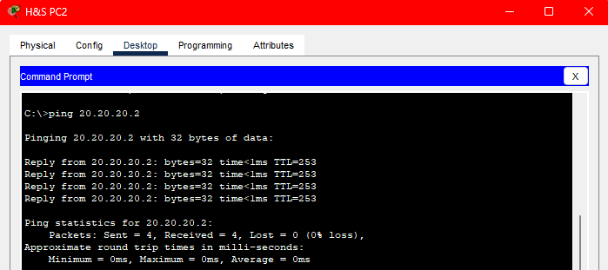

# Ping From Main Campus Departments to Branch Campus Departments

# Ping From Main Campus Departments to DMZ Servers

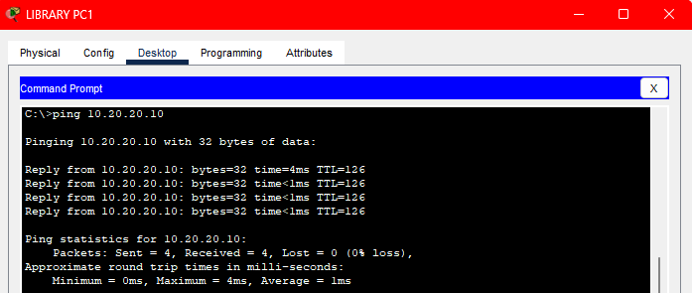

# Ping From Management Department to Main Campus Departments

# Ping From Management Department to Branch Campus Departments

# Ping From Management Department to DMZ Servers

# Ping From Branch Campus Departments to Main Campus Departments

# Ping From Branch Campus to Branch Campus Internet Router

# Ping From Branch Campus Departments to DMZ Servers

